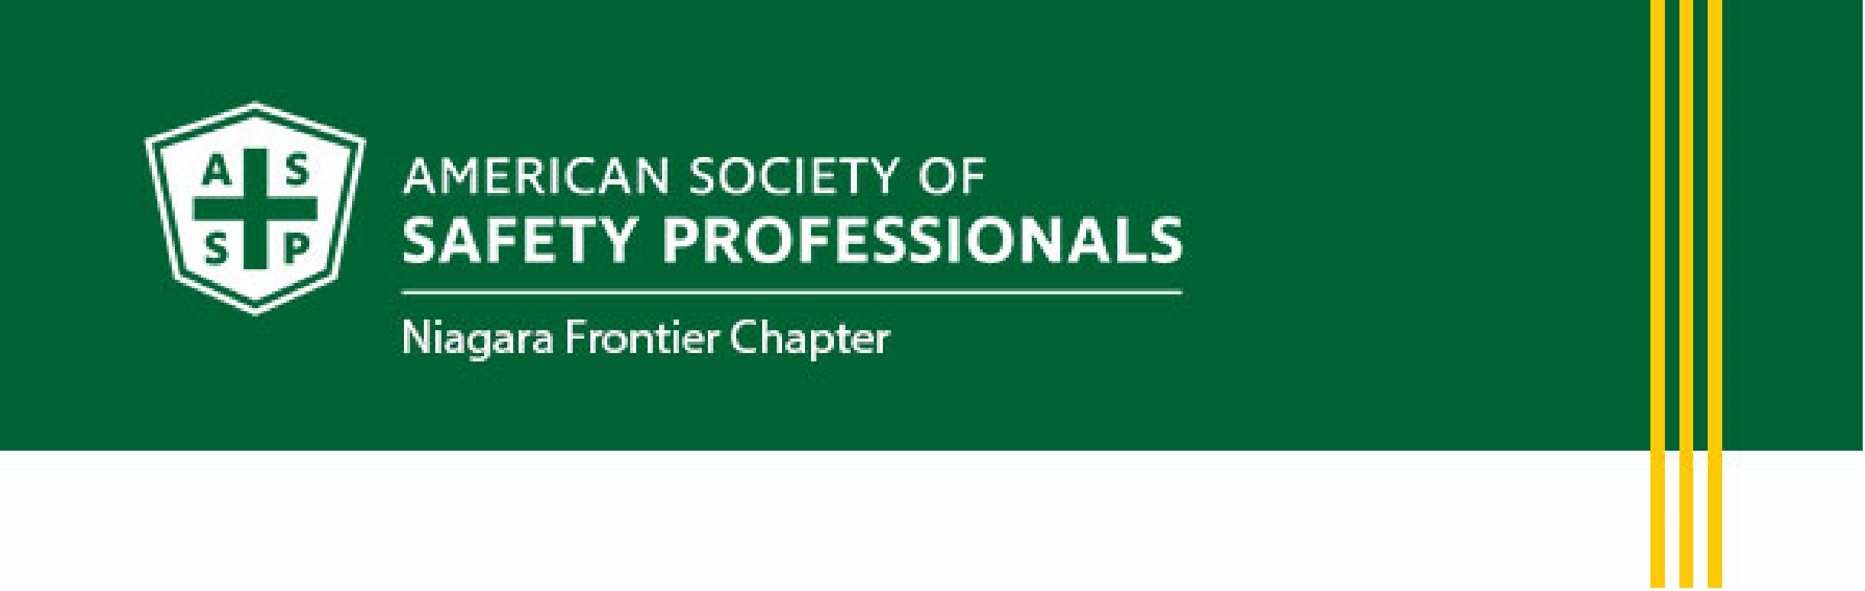

September Meeting Announcement
Thursday, September 17, 2026
Diamond Hawk Golf Course & Pub 255 Sonwil Dr.
Cheektowaga, NY 14225

11:30am Networking | 12:00pm Lunch
12:45pm OSHA Presentation

Guest Speaker
Mr. Michael Scime
Area Director, US Department of Labor, OSHA, Buffalo Area Office

Mr. Scime will be speaking on the state of safety and health in the Buffalo Region and the US, and will provide the latest OSHA updates. His presentation will include a Question & Answer session

Lunch:
Bone in BBQ chicken, salad and side, soft drinks or Veggie burger

ASSP Member $20, Non-member $25, Attendee (no lunch) $5
Cash or check (payable to: ASSE)

RSVP: president.nfassp@gmail.com by September 10th
Please indicate Veggie Burger in reply if interested in that option

Next meeting: October 15, 2026, 9:00am
Buffalo Niagara International Airport - Details to follow

